R INTEGRATION TO KNIME

Content

Section 1: Direct integration of the R script into Knime ---------------------------pg2

Section 2: Recreating the output of the R script only using Knime nodes -------pg9

### Section 1: Direct integration of the R script into Knime

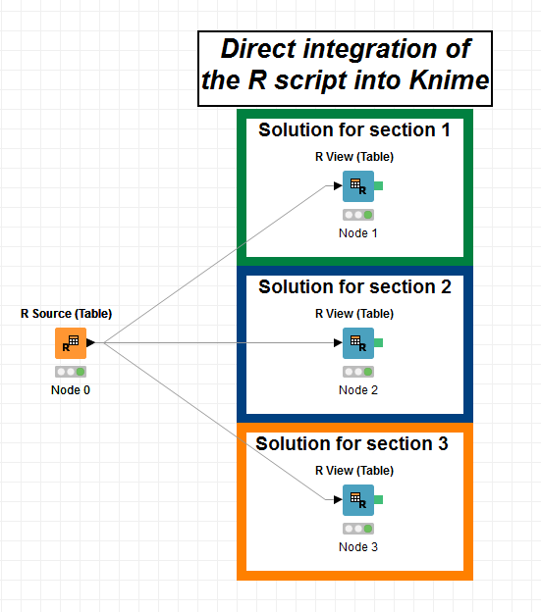***MODEL 1*:**

Node 0:

Script: - Extracts the SAS data file

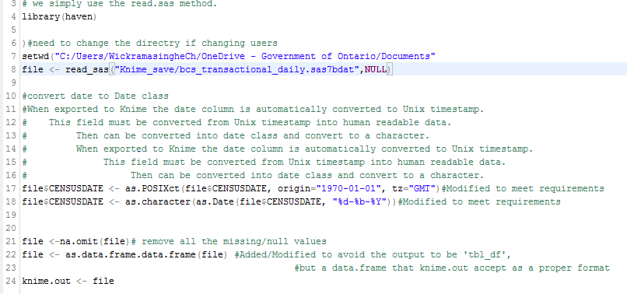

Node 1(Solution for section 1):

Script: - Creates a scatter plot

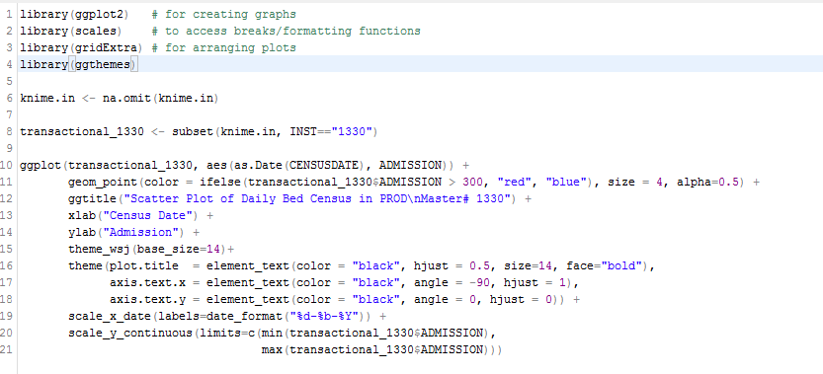

Output: -

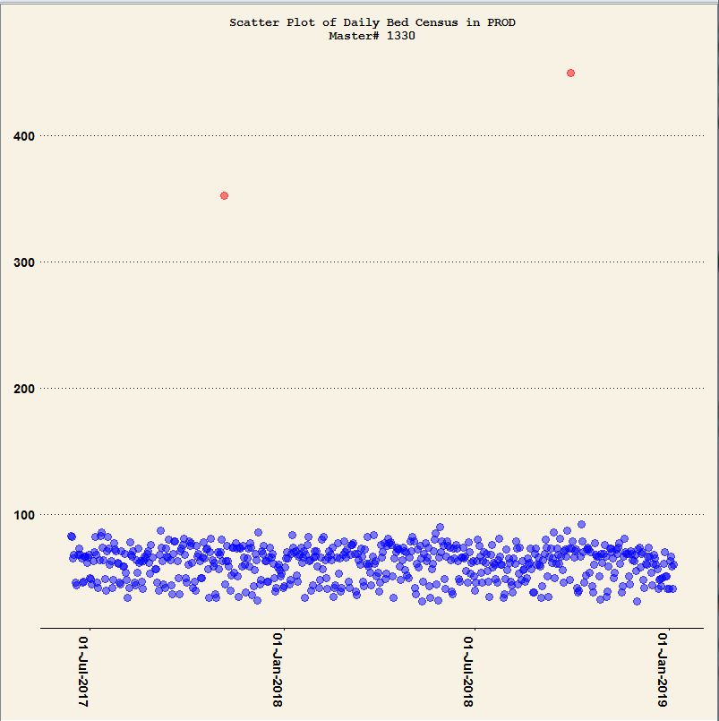

Node 2(Solution for section 2):

Script: - Create a box plot for one institute

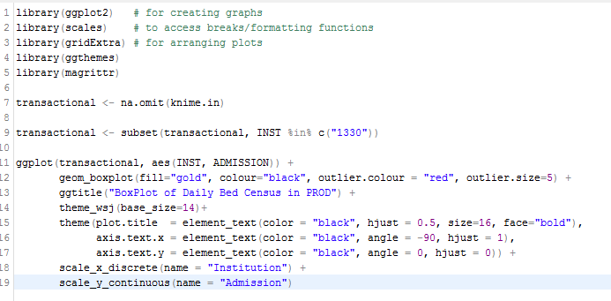

Output: - 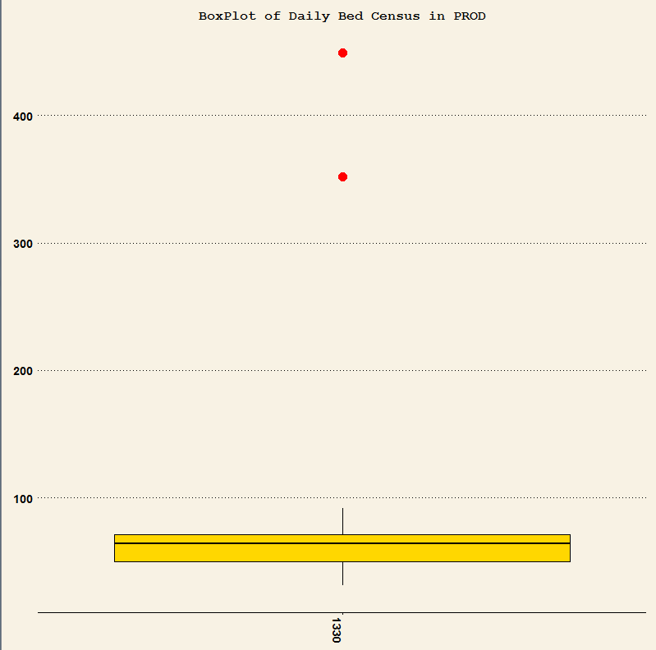

Node 3(Solution for section 3):

Script: - Create multiple box plots for all the institutes in a range

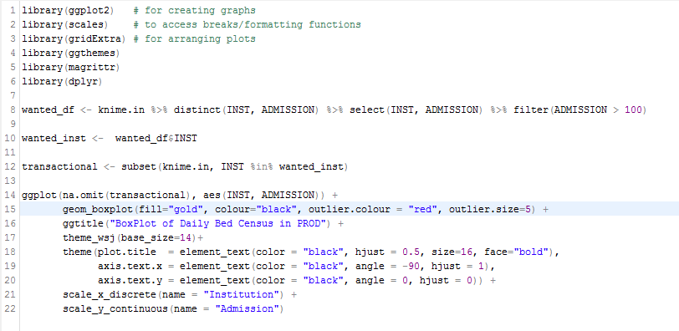

Output:

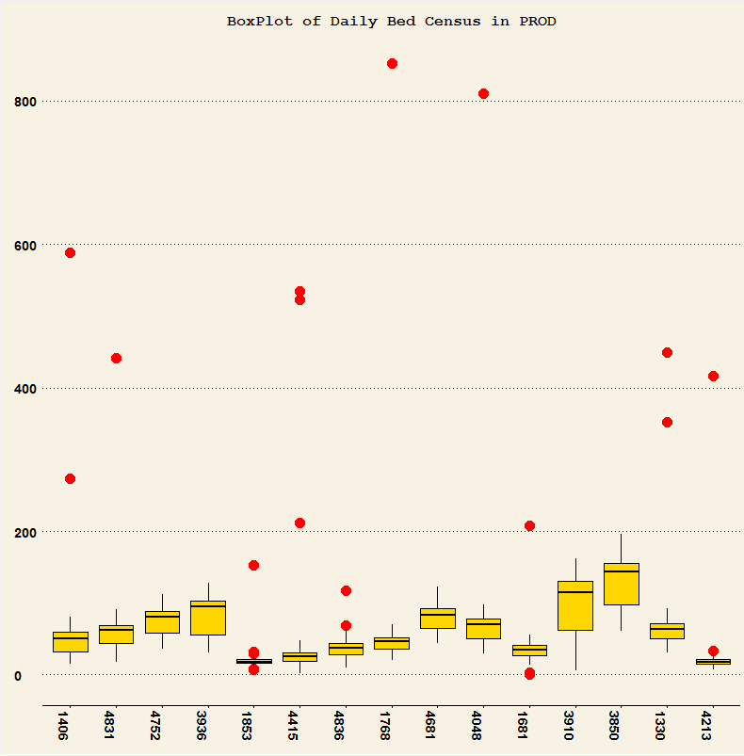

### 

### Section 2: Recreating the output of the R script only using Knime nodes.

***MODEL 2:***

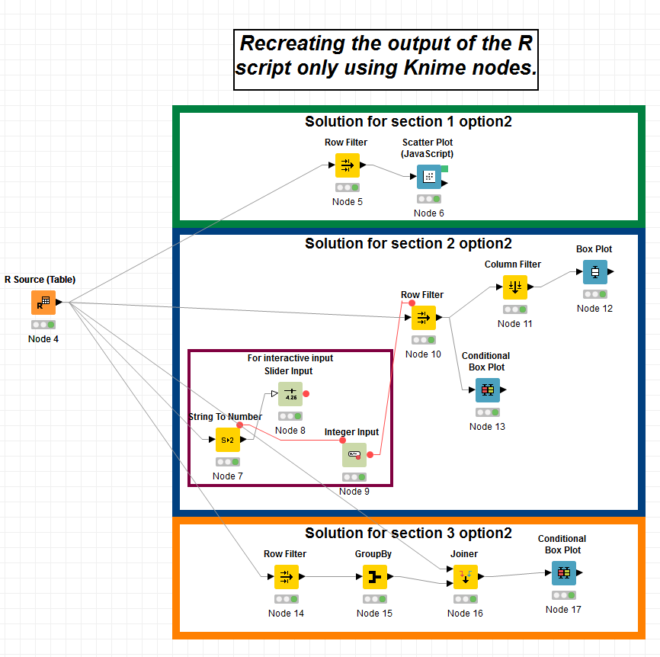

Node 4 == Node 0(Script: - Extract the SAS data file)

***Solution for section 1 option 2***

Node 5: - Filter the data needed (E.g.: INST=1330)

Node 6: Creates the scatter plot similar to the section 1 in MODEL1

Output:

Features-Can zoom in and out

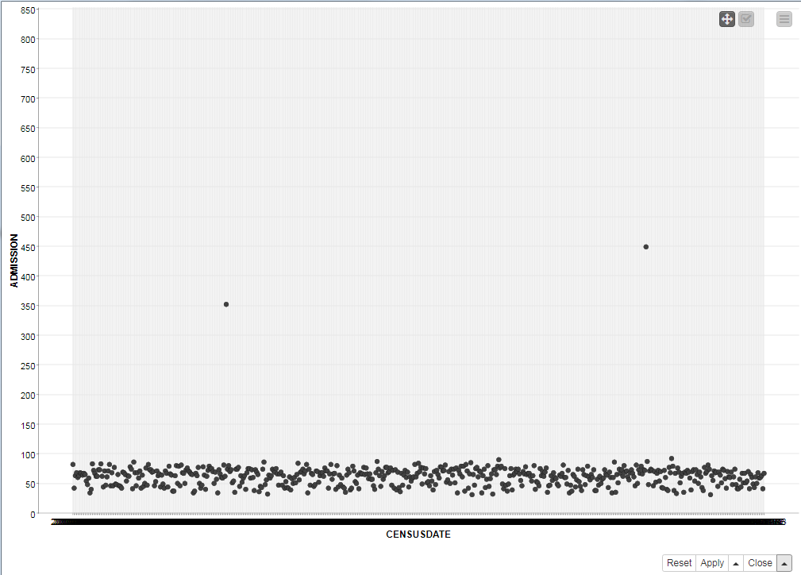

Additional

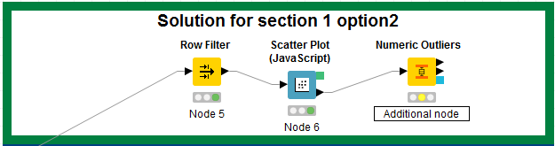

This node can extract the data and tell how many outliers are in the data set. Further analysis can be done using other nodes.

***Solution for section 2 option 2***

Node 7, Node 8, Node 9: - Show the ability to create an interactive input. User can give a specific value (E.g.: Give an Institute number) to process and create the specific box plot.

Node 10, Node11: Filter the data as needed.

Node 12/ Node 13: Create the box plot similar to the section 2 in MODEL 1

Output:

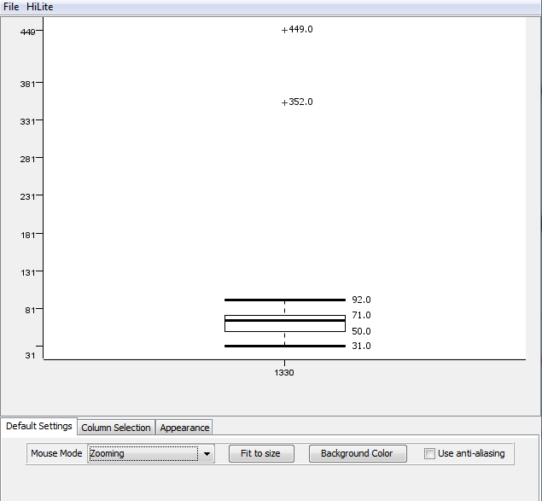

Features- Have different mouse modes and can change the background color as needed (User friendly).

***Solution for section 3 option 2***

Node 14, Node 15, Node 16: - Filter the data as needed

Node 17: Create multiple boxplots similar to section 3 in MODEL 1(NOTE: Can add/modify title and axis as needed)

Output:

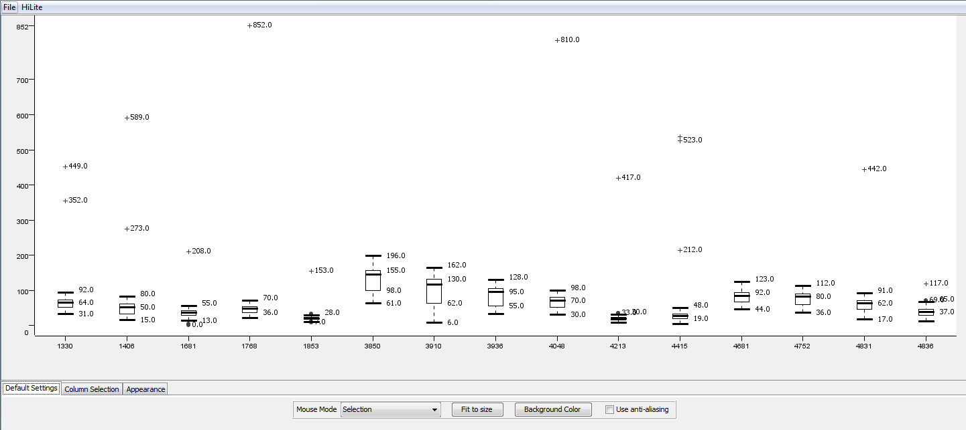

Features- Have different mouse modes, can change the background color as needed (User friendly) and filter only then necessary data as needed.

Following are some demonstrations,

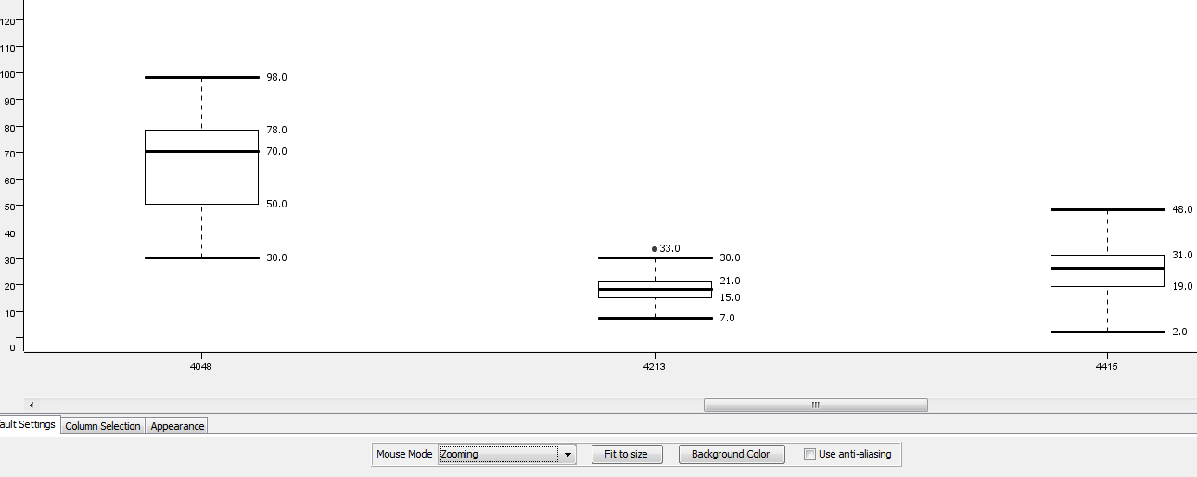

Can zoom into data sets.

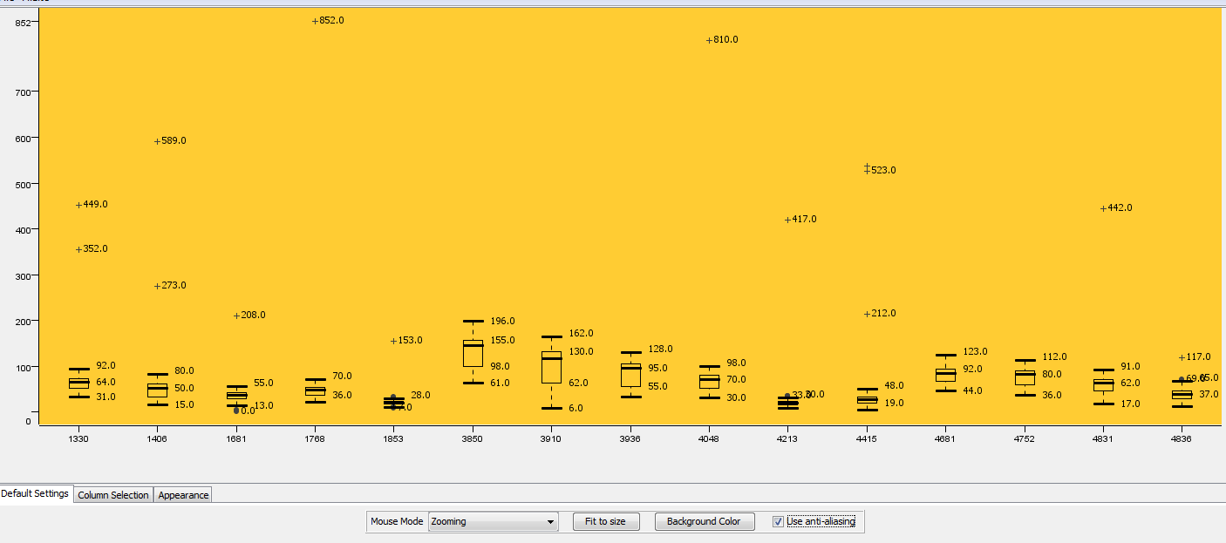

Change the background color.

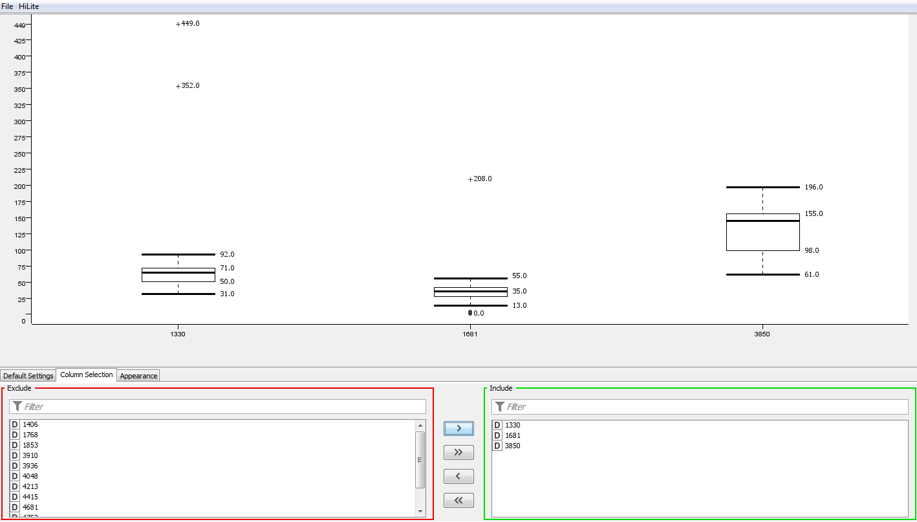

Can filter the necessary data as needed.

Next steps: Exploring/Creating other possibilities and Create reports in Knime that can be using to share.

***Conclusion:*** A ready made R script can be easily integrated into Knime and Knime could recreate the output(interactive) without any R script.